**Test Execution Using Jenkins**

**Step 1 - Open Web Browser** and then Navigate to below and Sign-in

<http://localhost:8080>

**Step 2 - Click on > Manage Jenkins**



* Click on > Global Tool Configurations

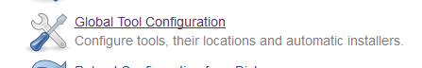

* Navigate to JDK Section And Click on Add JDK Button



* Uncheck Install Automatically check box. Give the name as JAVA_HOME and specify the JDK path.

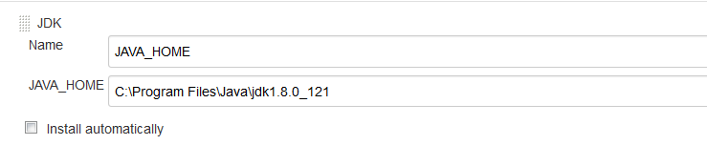

* Click on Save and Apply.



**Step 3 - Create New Batch file**

* Open command Prompt and set the class path
* Ex. Home directory > set classpath= C:\Users\Priti\workspace\Purchase\bin; C:\Users\Priti\workspace\Purchase\libs\*;
* Open Notepad and type the below command and save as .bat file

Ex: java-cp bin; libs/*org. testng.TestNG testng.xml (“**testng.xml” file will be our test suite file name**)

Note : I have saved as run.bat

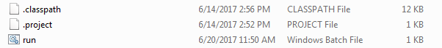

**Step 4 – Create a job** in Jenkins which will execute our build

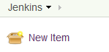

* Give the name ,select Build as free-style software project and click on OK button.

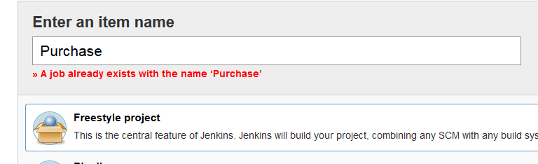

* Navigate to Advance Project Options> Check the use custom workspace > in directory we will specify the project home directory

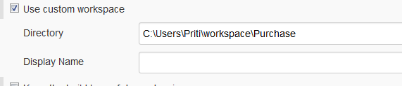

* Add Build Step > Click on Execute Window Batch command

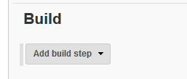

* Enter batch file name which we are created and click on Apply and save

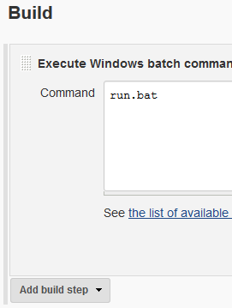

**Step 4 – Run the Build >Click on Build now option**



**Step 5 – Check Build history and Console output and verify the output**

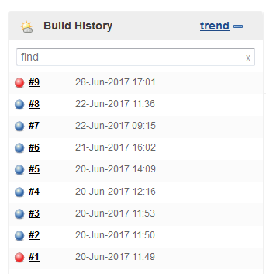

**Step 6 – Check Report and verify**

* In Jenkins, Go to Project > Workspace > Report